UBER DRIVING ANALYSIS

1 INTRODUCTION:

* 1. Overview :

The ride-sharing business revolutionized a

Business model that had been functioning in the

Same way for generations: on a busy city Street ,a person in need of a ride stood on a street corner and waved down a taxi. On quieter streets, or in towns without roving taxis, the person. Uber is a

Multinational network company that operator a ride-hailing platform .Uber’s data can be analyzed

On a daily, weekly, monthly basis to understand the trends and patterns of trip volume.

1.2 purpose:

Uber is a transportation company with an app allows passengers to hail a ride and drivers to change fares and get paid. More specifically, Uber is a ridesharing company that hires independent contractors as drivers.

1. PROBLEM DEFINITION & DESIGN THINKING:

2.1 EMPATHY MAP

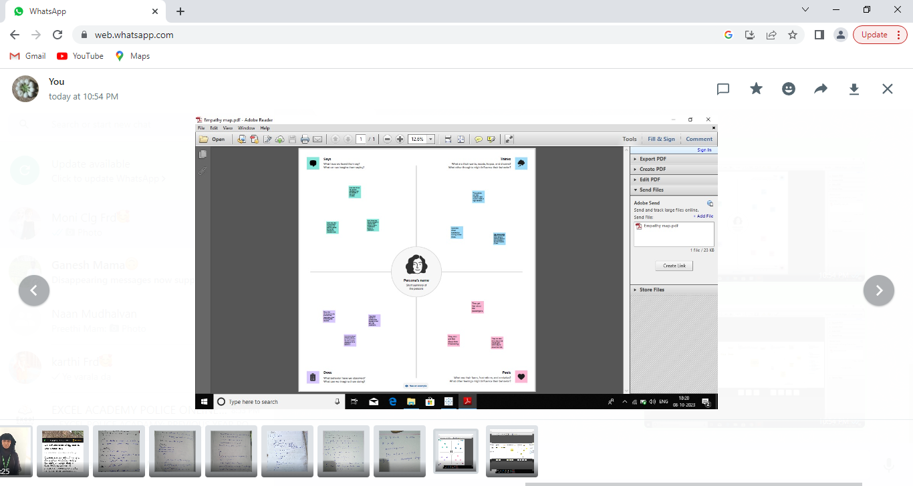

2.2 IDEATION & BRAINSTORMING MAP:

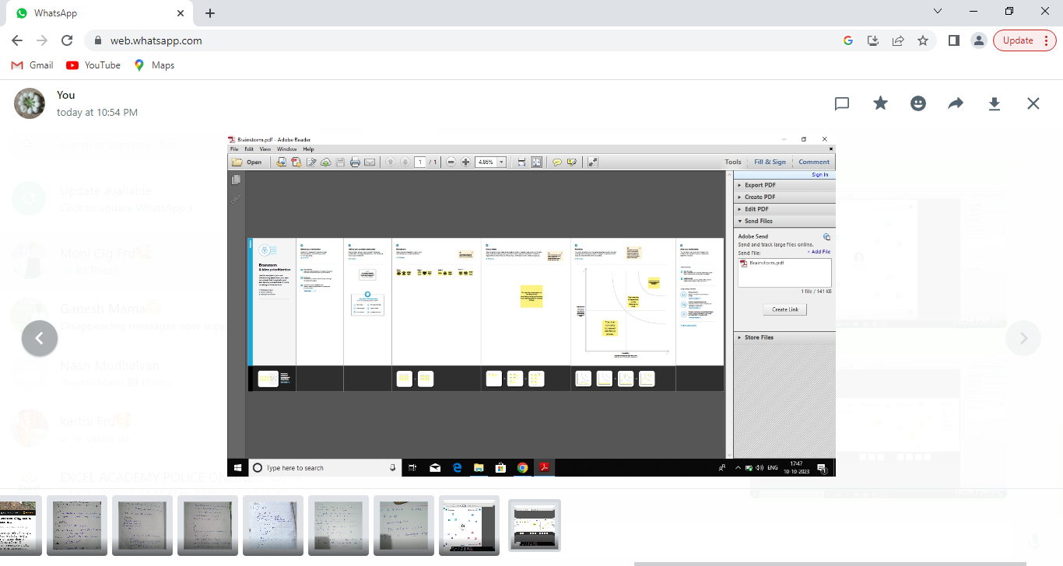

1. RESULTS:

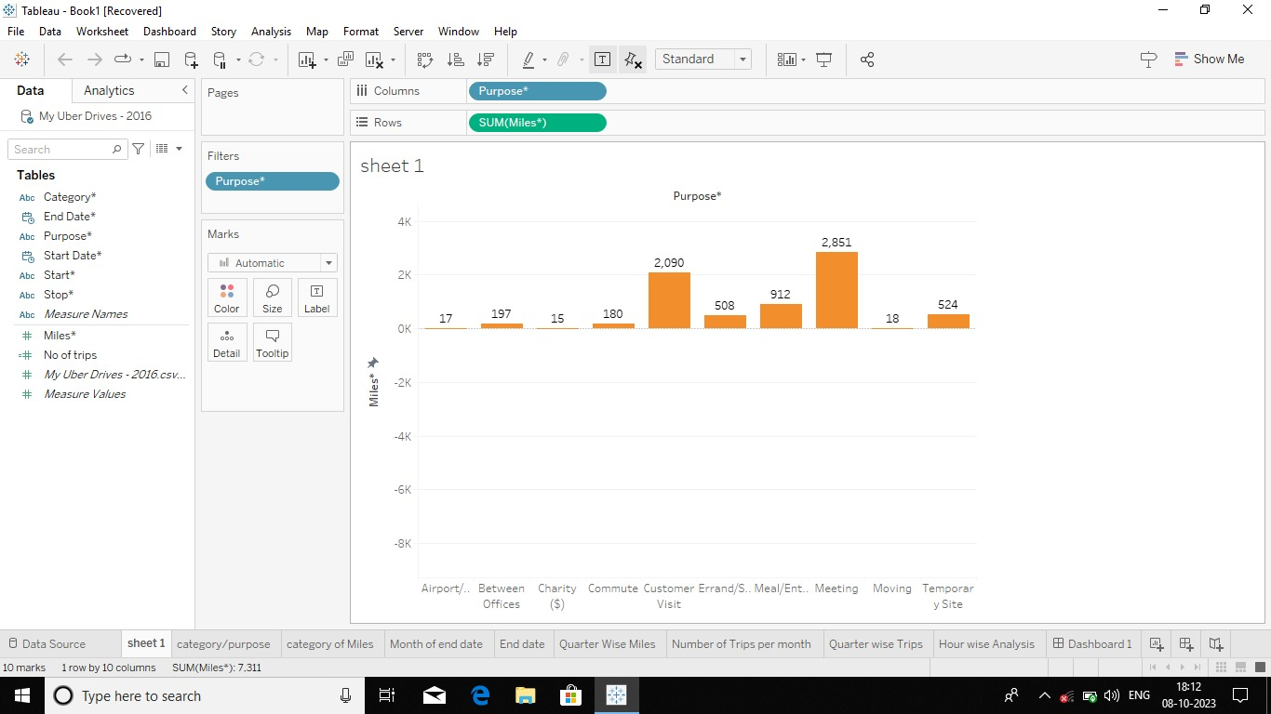

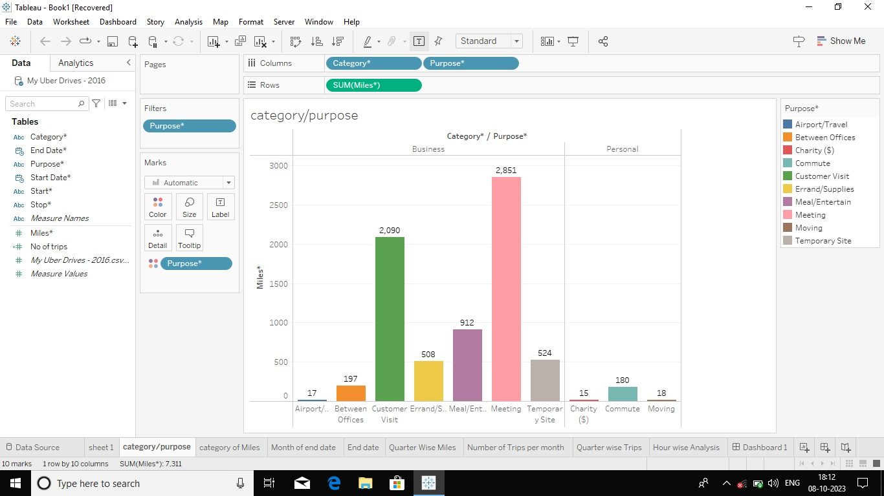

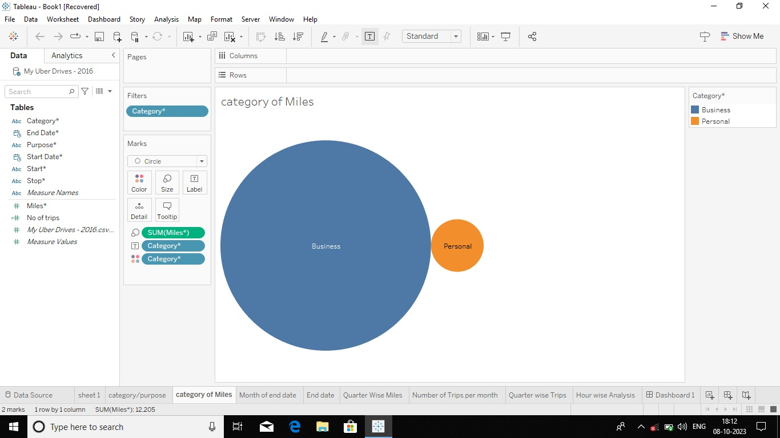

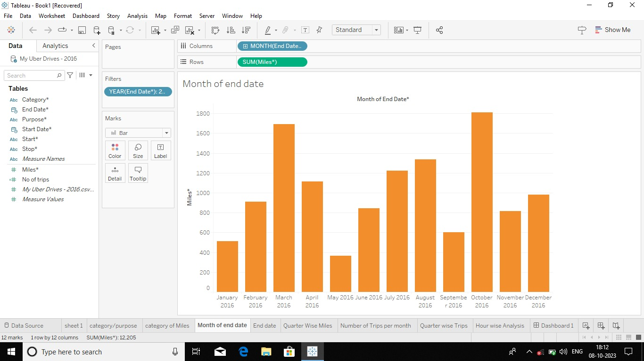

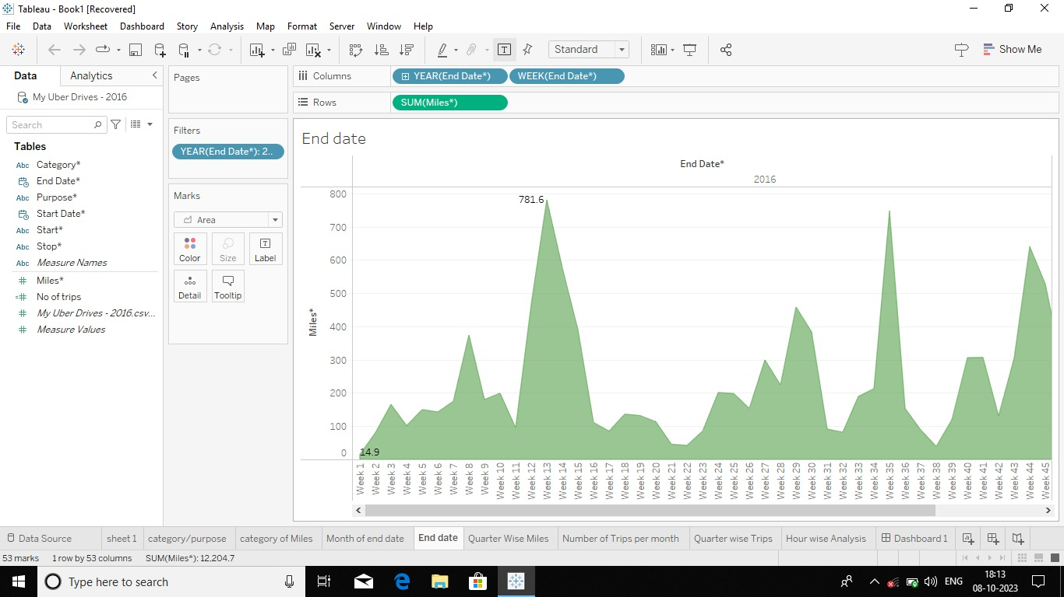

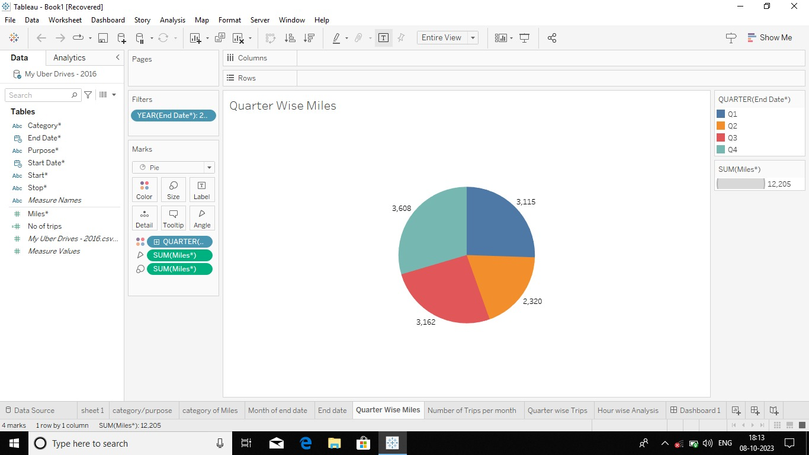

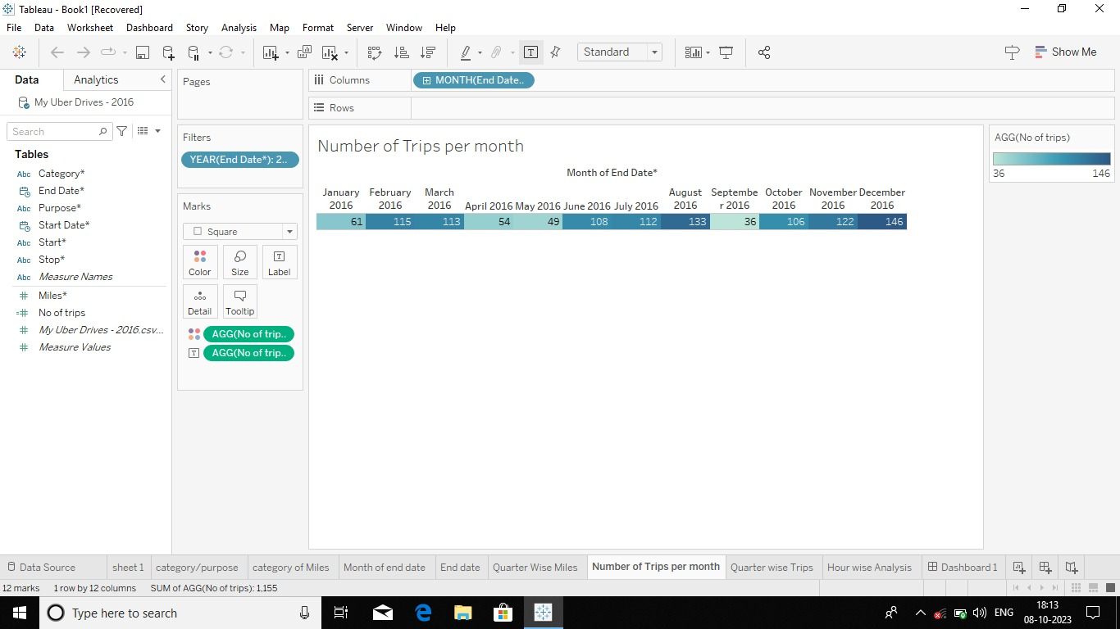

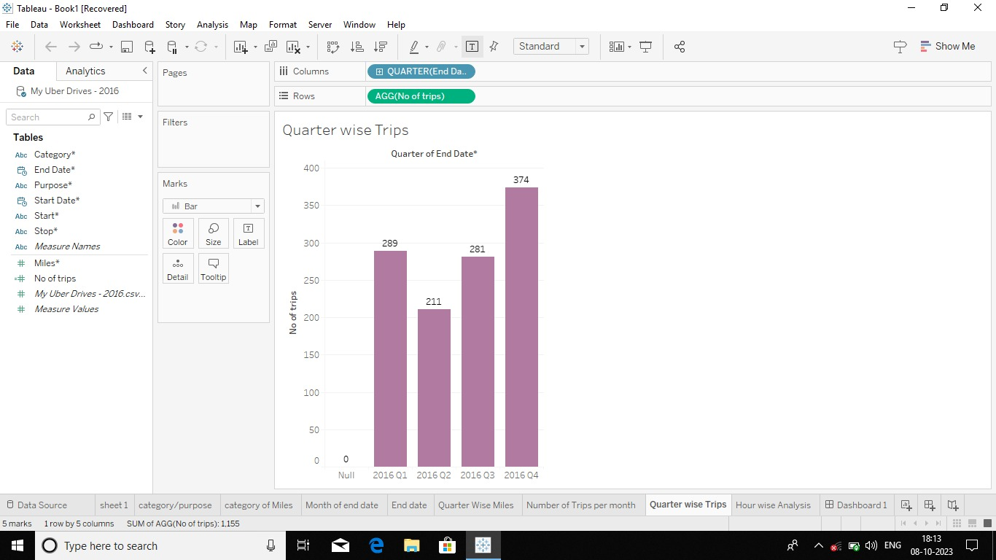

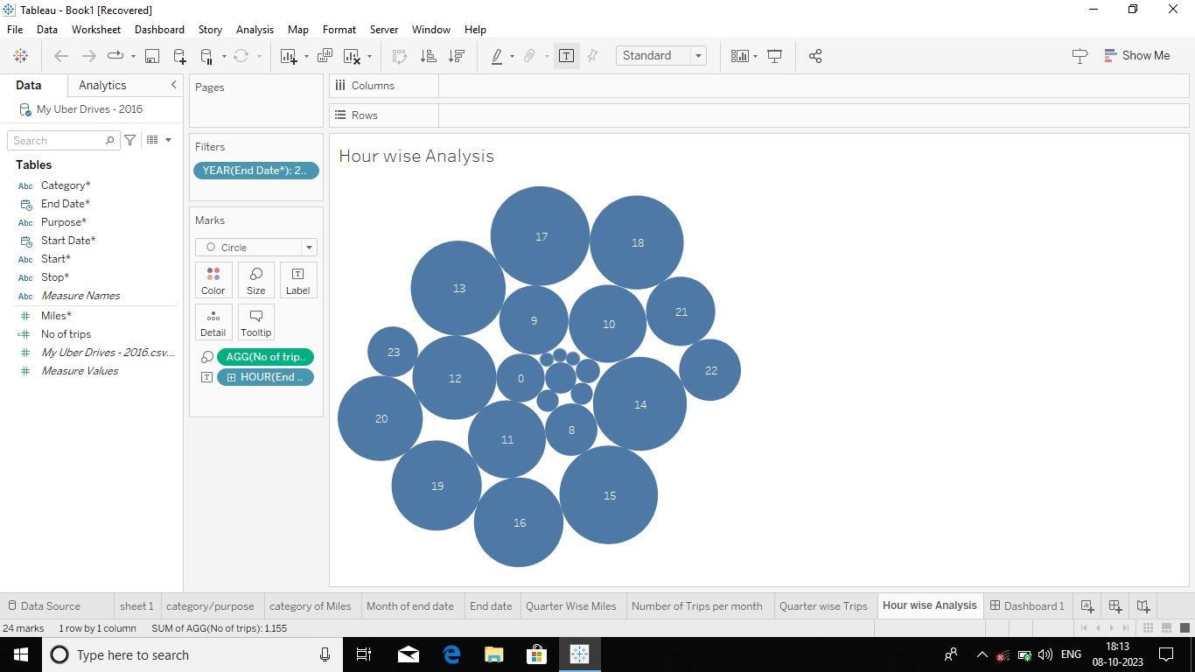

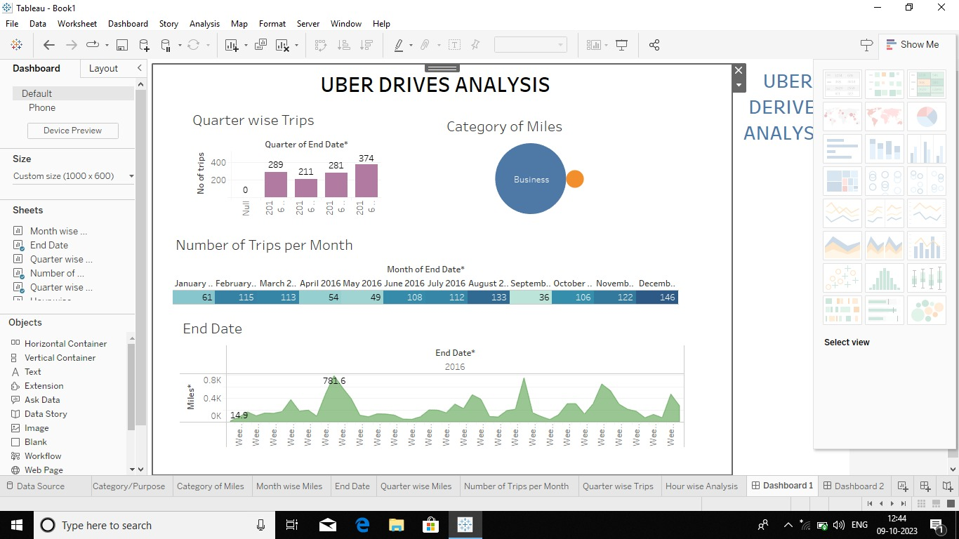

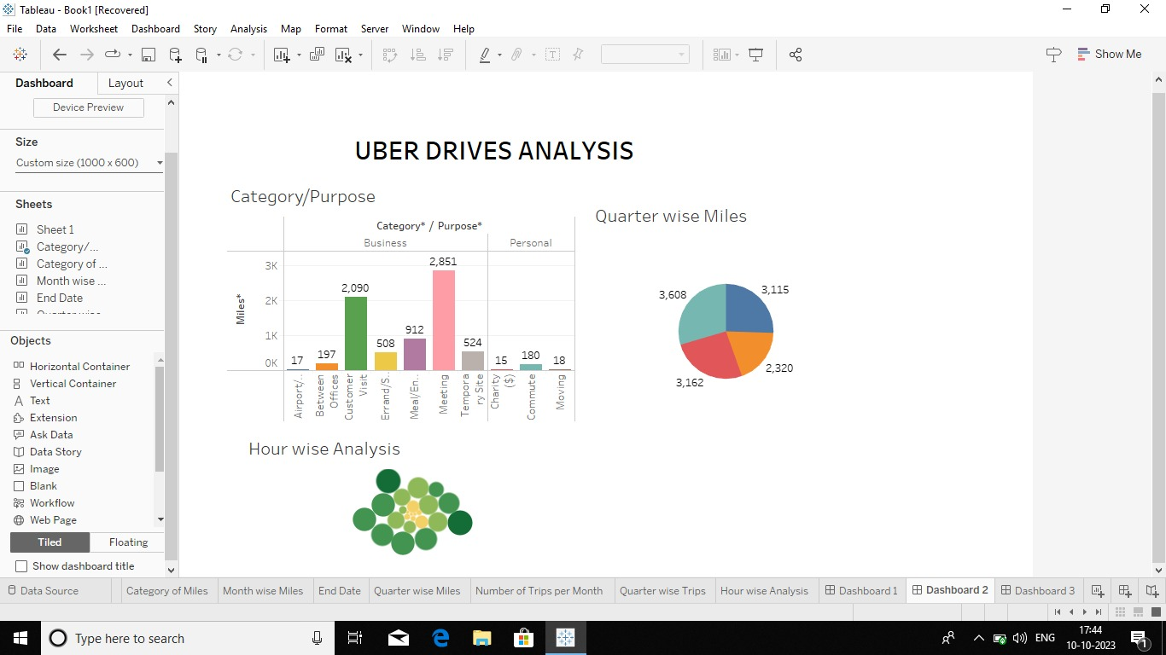

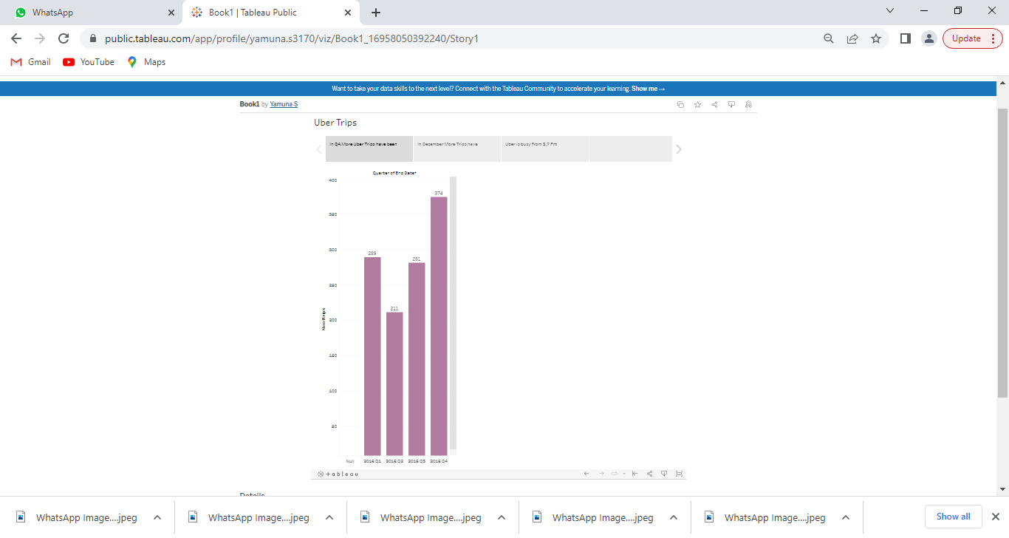

1. ADVANTAGES & DISADVANTAGES:

Uber’s advantages include door-to-door convenience, safety and reliable quality. Uber doesn’t even need to ask you for an address. It knows where you are. Safety is an important advantages for drivers working with Uber and other e-hail services.

DISADVATAGES:

Uber’s disadvantages include its surge pricing and the negative effects of replacing steady job with gig work. “Surge Pricing” for Uber, or “Prime Time Pricing” as it is called by left is controversial among customers. Competition from other ride-sharing services and the continuous hiring of new drivers, average earnings are being pushed downward.

1. APPLICATIONS:

Uber Technologies provides ride-hailling services, food delivery and freight transport. The main purpose is a great way to make your travel plans stress-free. Uber links passengers with drivers using the Uber app. Generally, the drivers own their own car. The company does also offer rental or lease on cars through third party partners like Hertz, Get Around and Fair. Uber Fleet is an app for those managing squads of drivers.

1. CONCLUSION:

We loaded the dataset containing Uber rider and performed data cleaning and preprocessing steps. We applied various descriptive statistics and data visualization techniques to perform EDA on the data to generate insights form it.

1. FUTURE SCOPE:

We can use this data for training a model using ML and building a smart AI based predictive system. Model can automatically send the insights to the authorities or drivers related to areas having most trips and passenger count in certain areas. This big data can be used to study passenger’s behavior.